I’m currently stuck in a boring DB training class. So I decided to do some Vault app programming to avoid slipping into a coma. The result is Effective Permissions 2013. It’s an update of my Effective Folder Permissions 2.0. The ‘Folder’ part of the name has been dropped since it now does more than just folder permissions.
Check out the video:
The main new addition is a view/edit window for object permissions. You can now edit an Access Control List and see the effect before you commit the change. It’s also smart enough to determine the source of the ACL.
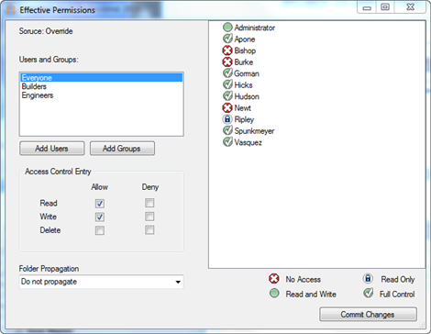
All the old features are still there. So you can still see the Administrators List, and you still have the Permissions Overview, which shows the user-based permissions for a set of folders.
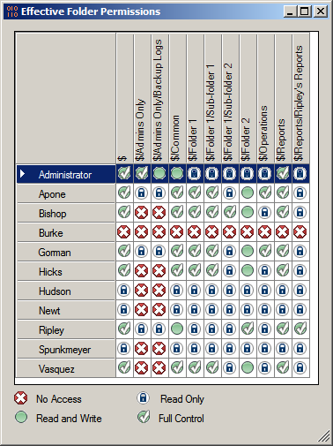

Requirements:
- Vault 2013 Workgroup / Collaboration / Professional
- Administrative Rights
Click here to download the application
Click here to download the source code
Click here for 2011 version
As with all the samples on this site, the legal disclaimer applies.

